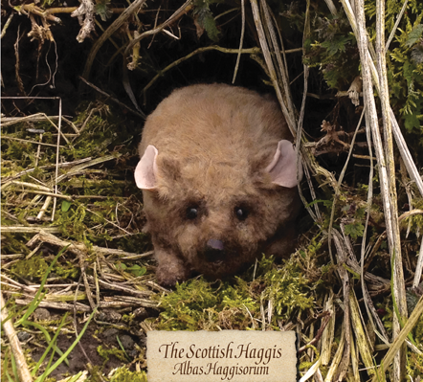

Clarkston Nursery Haggis Hurl
27th November 2020

Your child is invited to take part in our annual Haggis Hurl in celebration of St Andrews day on 27th of November. (Or the last day they’re in nursery that week) I’m SO sorry we can’t invite you in to cheer us on this year – but at least the wee ones will have some fun!! There will also be a treat table and an honesty box at the front door – thanks to our lovely fundraisers for organising. We’re really curtailed in our fundraising activities this year, so any sponsorship you can muster will be very much appreciated.

Childs Name:

Sponsor | Donation | Tick if you are a tax payer *
*This will allow the nursery to claim Gift Aid on your donation.

